**CSCI 477 – Games and Game Development**

**Assignment 6**

In this assignment, as requested I implemented Dijkstra’s Algorithm. The only thing that made me struggle was the Decrease-Key operation in the algorithm which I solved using a vector for queue and sort it again in the loop in each iteration.

Test Plan: I used the graph of TEST1 which I had implemented for Assignment 5 to test my algorithm.

**Case #1**: Same vertex name given:

**Input**: PATH - Atlanta - Atlanta

**Expected** **Output**:

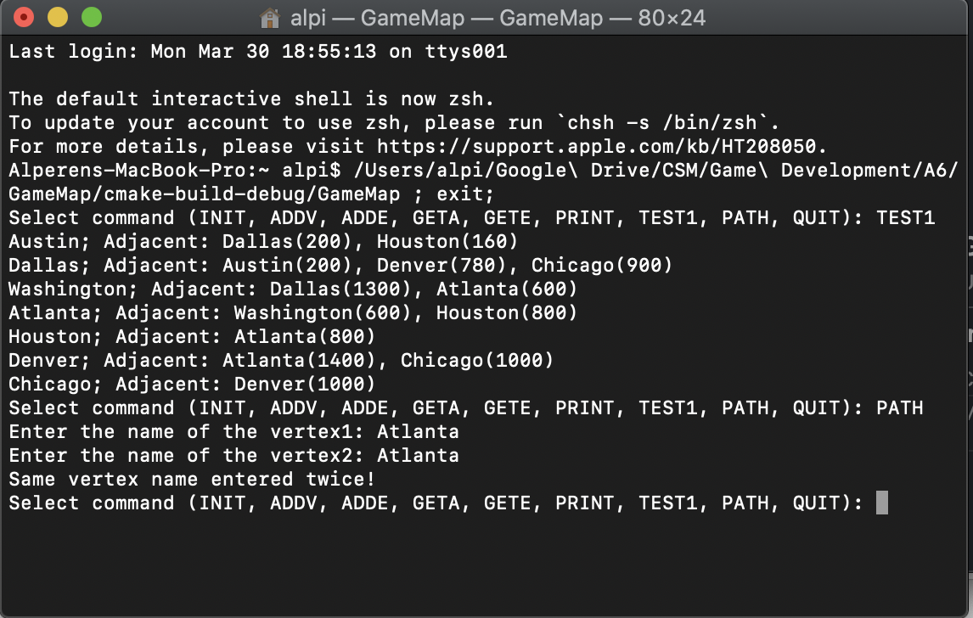Same vertex name entered twice!

**Case #2:** Possible circular path that can cause infinite loop: For example Austin and Denver has path to each other and the algorithm can assign each other’s parent as on another.

**Input:** PATH - Austin - Dallas

**Expected Output:**

The optimum path from Austin to Dallas : Dallas

The total distance is: 200 miles.

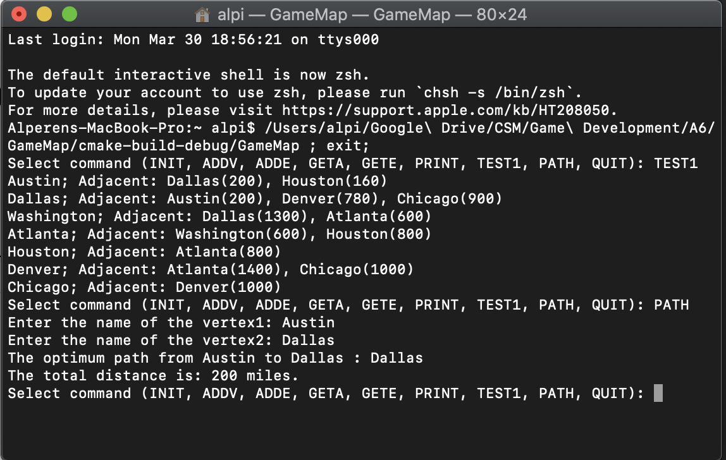

**Case #3**: A long path.

**Input**: PATH - Dallas - Washington

**Expected** **Output**:

The optimum path from Dallas to Washington : Austin -> Houston -> Atlanta -> Washington

The total distance is: 1760 miles.

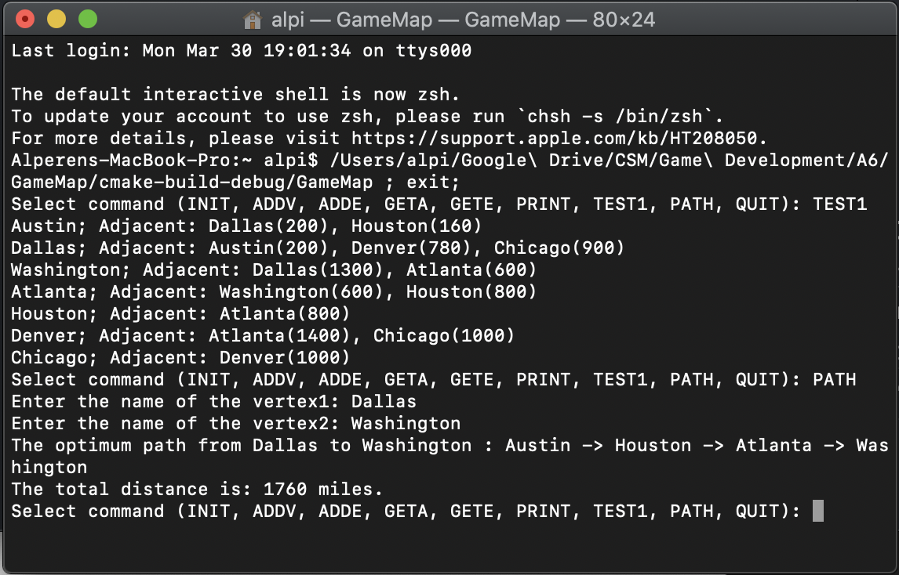

As can be seen from the screenshots, the algorithm I implemented passes all test cases.